Report Parallel Execution

by Aliaksandr Labayeu

## Parallel SELECT

Execution plan for **simple** SELECT from Fact Table

Also enabling AUTOTRACE ON so as get statistics after execution

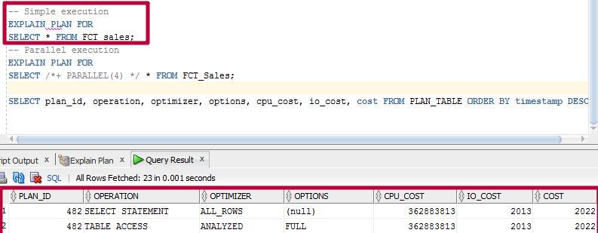

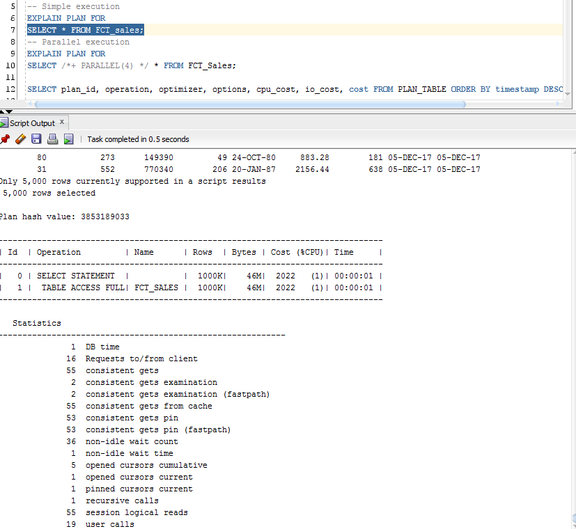

Execution plan for **parallel** SELECT from Fact Table

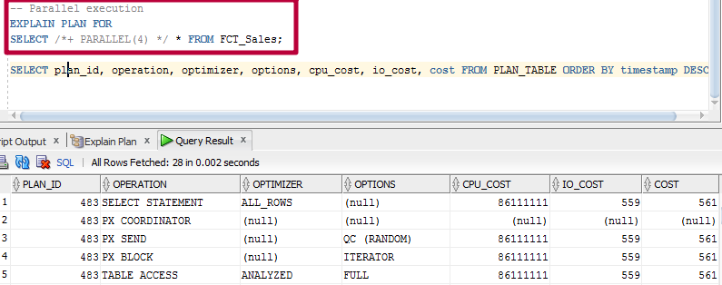

As it shown above, parallel execution gives us a significant gain in performance.

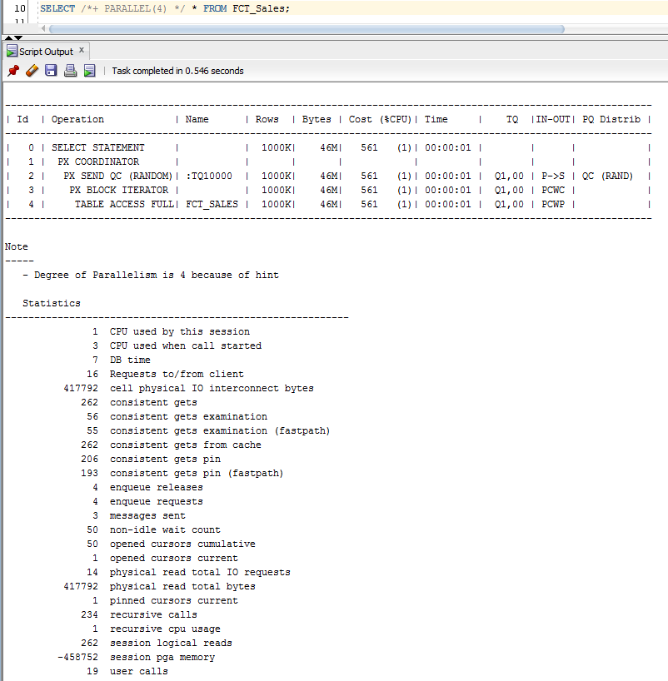

Here we can also see the degree of parallelism and other informatin

## Parallel DDL

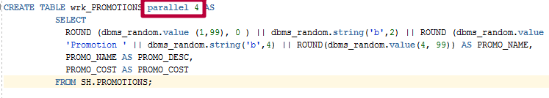

Using parallel 4 in wrk_Promotion table will make it possible to speed up operations because of splitting tasks of operating with new promotions. Promotion is an essential part of every reseller company and it is expected to have a great rise in promotions in near future, so parallelism is going to be used in promotions.

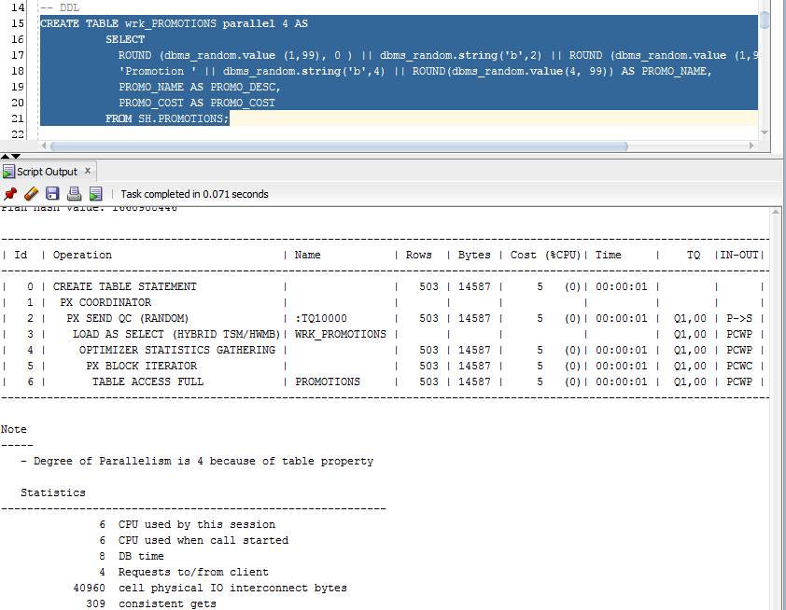

Create table without parallelism:

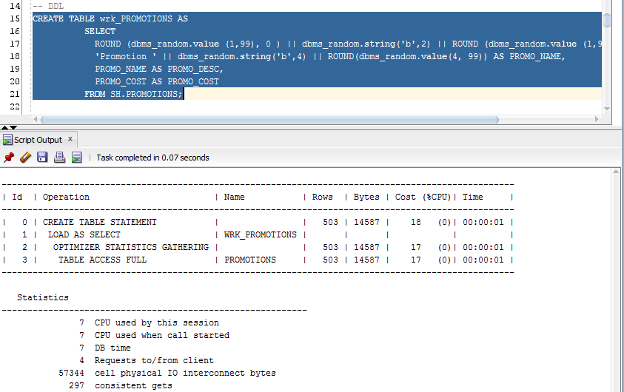

Cost without parallelism also rises a lot.

## Parallel DML

Parallelism in DML statements need to be used with Consumers table on the step of inserting data to CLS layer, because of great amount of Consumers (50.000) and JOIN operations on this layer. Simple INSERT statement requires too much time to insert all this data, when Parallelism helps to speed up this action.

1. INSERT without parallelism

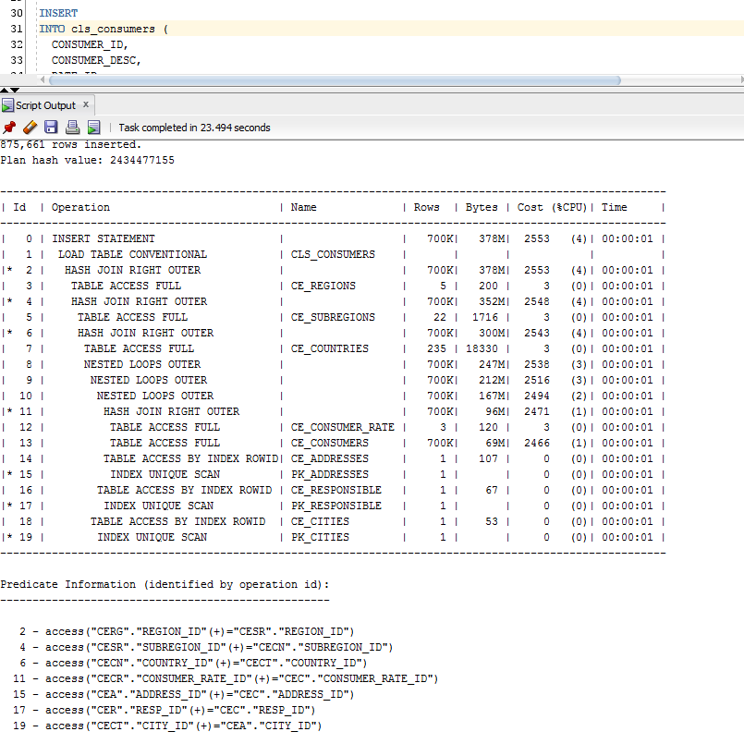

1. INSERT with parallelism

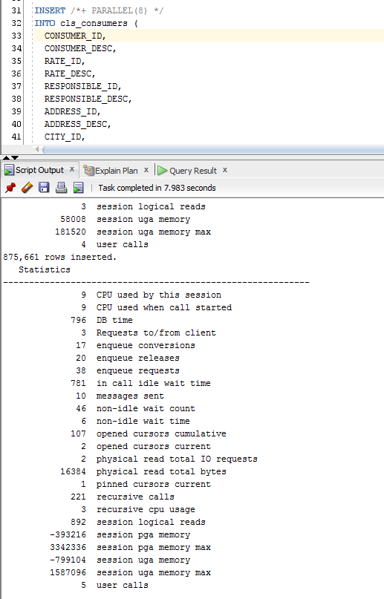

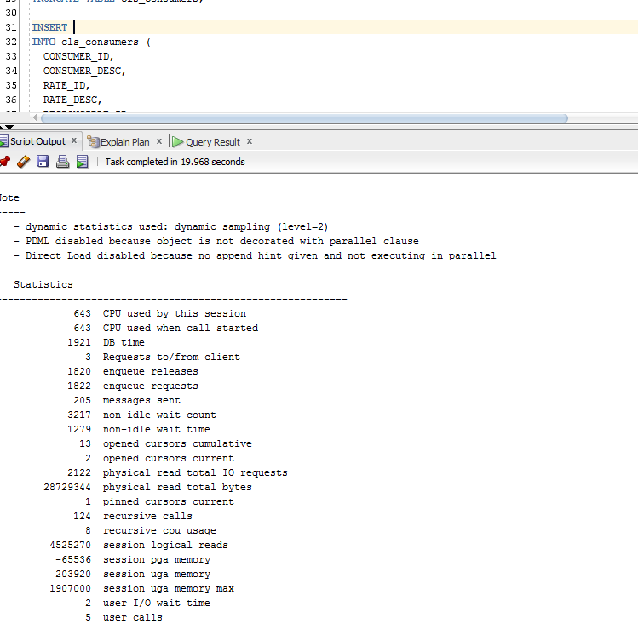

Numbers shows us great difference between this two ways of inserting data. Parallelism will be used to insert Consumers because of the great amount of records there.